

Conference App Download Instructions


APPLE STORE
- Search for “AAHHE” or scan the QR code below
  - You should see “AAHHE” in the results
- Click on ‘GET’
- Download the app to your phone
- Open the app
- Click the profile icon located at the top right of the app home page to log in
  - Follow the prompts on the screen to obtain an access code
    - Make sure to use the email you registered with
  - Enter the access code sent to your email
- You should now have access to the event
  - Now that you’re logged in, you can make edits to your profile by clicking on the profile button at the top right of the home page

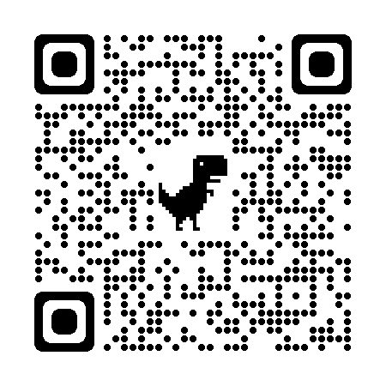
GOOGLE PLAY STORE
- Search for “AAHHE” or scan the QR Code below
  - You should see “AAHHE” in the results. If the app does not appear in the search results, use quotes around the app name.
- Click on ‘Install’
- Download the app to your phone
- Click on ‘open’
- Click the profile icon located at the top right of the app home page to log in
  - Follow the prompts on the screen to obtain an access code
    - Make sure to use the email you registered with
  - Enter the access code sent to your email
- You should now have access to the event
  - Now that you’re logged in, you can make edits to your profile by clicking on the profile button at the top right of the home page

Note: Android version is 5.1 or later is required to run the app

